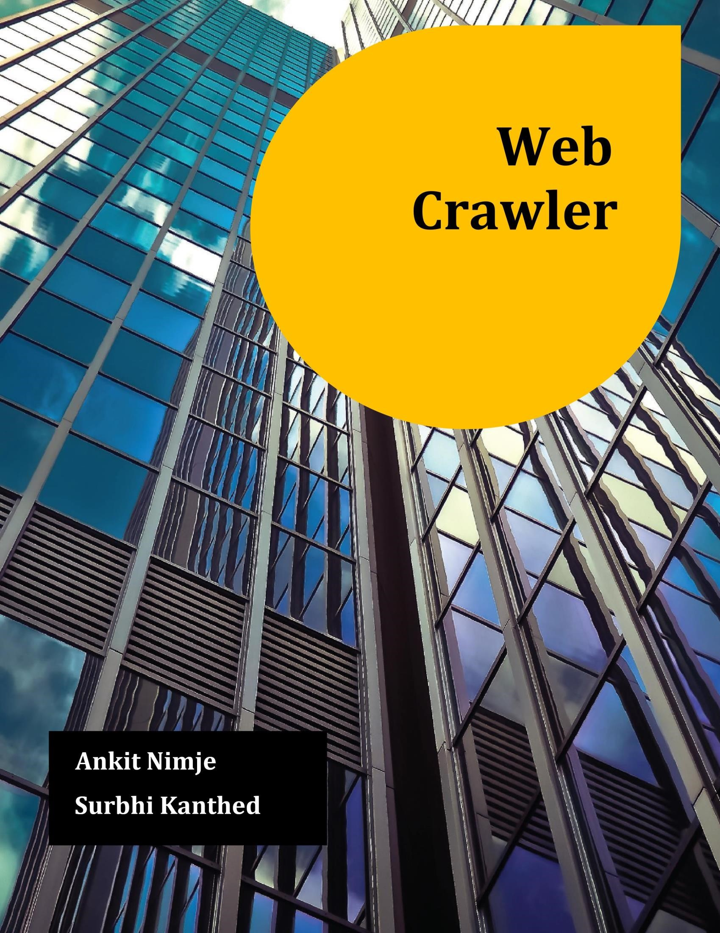

In this week, we worked on developing Front End / User Interface for our project. Using a simple search engine look-alike webpage with a text box which accepts query from user and provides to python program in the back end. For this designing, technologies such as Bootstrap, html, CSS, JavaScript are used. We are trying to add many advanced features which will mimic search engine bar, one of which is search suggestions. When user starts typing a query, a JavaScript function autoComplete() will dynamically look for keywords already in the bucket.

Problems Faced:

As we used HTML form type, thus it is required to use submit button to send input text value to back-end program. To make it more challenging and intriguing, we implemented another function which accepts input string with just hitting Enter key as like in many search engine platforms.

**References:**

1. S. Chakrabarti, M. Berg, and B. Dom,” Focused crawling: a new approach to topic specific Web resource discovery”, Computer Networks, vol. 31, pp. 1623-1640, 1999.
2. W3Schools Tutorials

3] Page Rank Algorithm and Implementation – Geeks for Geeks